**Effect of R on Q factor**

**Circuit A:**

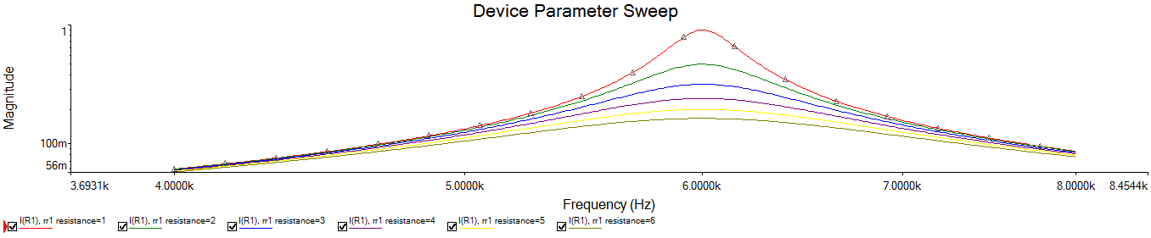

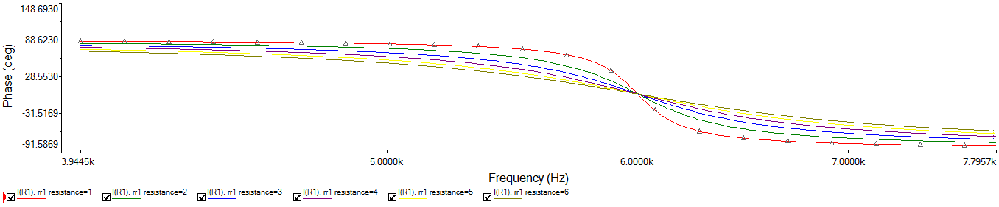

Questions:

1. Impact of R on:

1. Bandwidth: $BW=\frac{fr}{Q}=\frac{R}{2πL}$, thus BW is directly proportional to R
2. Quality Factor: $Q=\frac{1}{R}\sqrt{\frac{L}{C}}$, thus Q is inversely proportional to R
3. Selectivity: Selectivity is equivalent to Q factor, i.e.,

Selectivity $=\frac{fr}{BW}$ which is inversely proportional to R, i.e., a more selective circuit will have a narrower bandwidth whereas a less selective circuit will have a wider bandwidth

**Circuit B:**



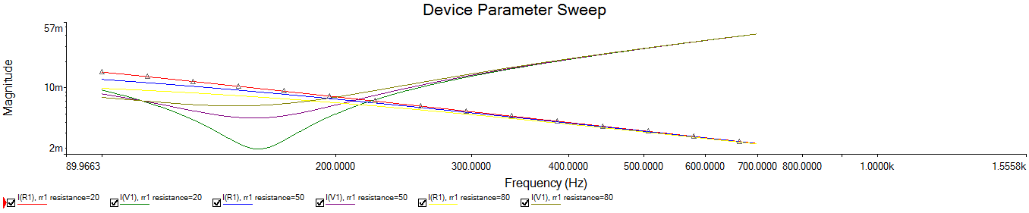

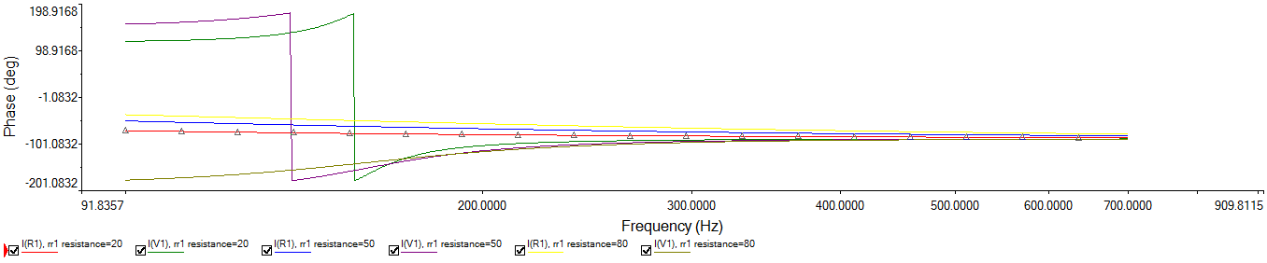

Questions:

1. Impact of R on:
2. Resonance frequency: $fr=\frac{1}{2π}\sqrt{\frac{1}{LC}-\frac{R^{2}}{L^{2}}}$, is decreases as R increases
3. Quality Factor: $Q=\frac{1}{R}\sqrt{\frac{C}{L}}$, thus Q is inversely proportional to R
4. Bandwidth: BW $=\frac{fr}{Q}=\frac{R}{2π}\sqrt{\frac{1}{C^{2}}-\frac{R^{2}}{LC}}$, thus BW will increase along with R till R = $\sqrt{\frac{L}{2C}}$, then it decreases as R increases.
5. Selectivity: Selectivity is equivalent to Q factor, i.e.,

Selectivity $=\frac{fr}{BW}$ will increase as R increase till R = $\sqrt{\frac{L}{2C}}$, then it decreases as R increases.

1. Yes, RLC circuit can be used as a filter due to its selectivity towards band and frequency.
2. RLC series circuit in the first experiment with R = 1 Ohm, acts as a **band pass filter** when output is taken across **R** as it allows a specific range of frequency, i.e., a specific band.
3. RLC parallel circuit in the second experiment acts as a **band stop filter** when output is taken across **capacitor**, as it rejects a specific range of frequency.
4. RLC parallel circuit in the second experiment acts as a **low pass filter** when output is taken across **Resistor**, as it allows lower frequencies and rejects higher frequencies.